Step1: Enter in the root mode using su command

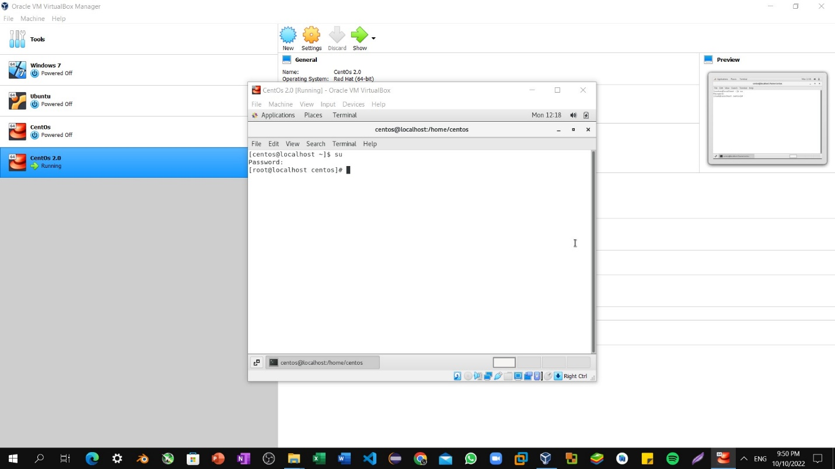

Step2: cat /etc/redhat-release: Enter the following Linux command to display the current operating system information and its version.

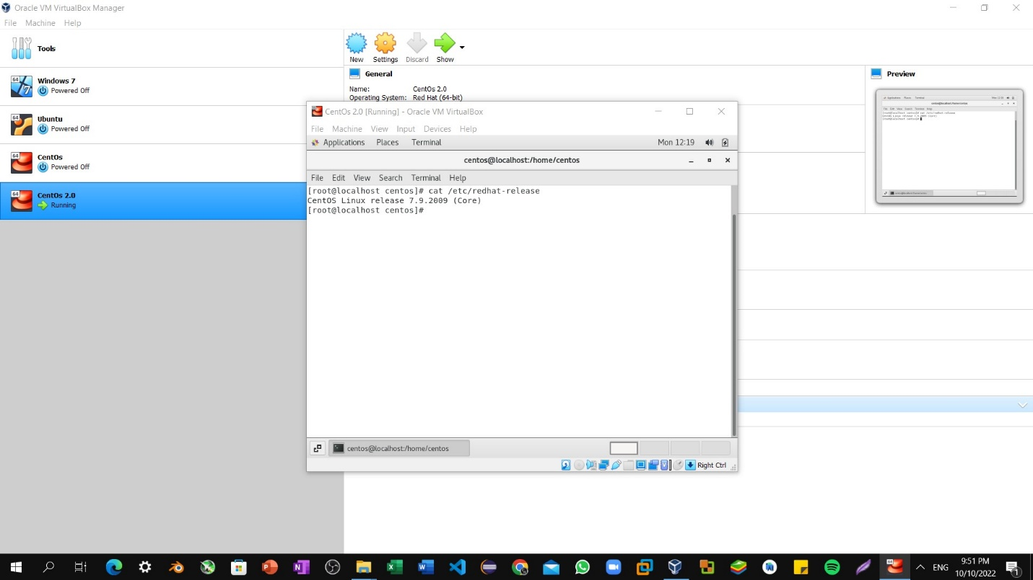

Step3: yum clean all: Enter the following commands in order for the operating system to be cleaned and updated.

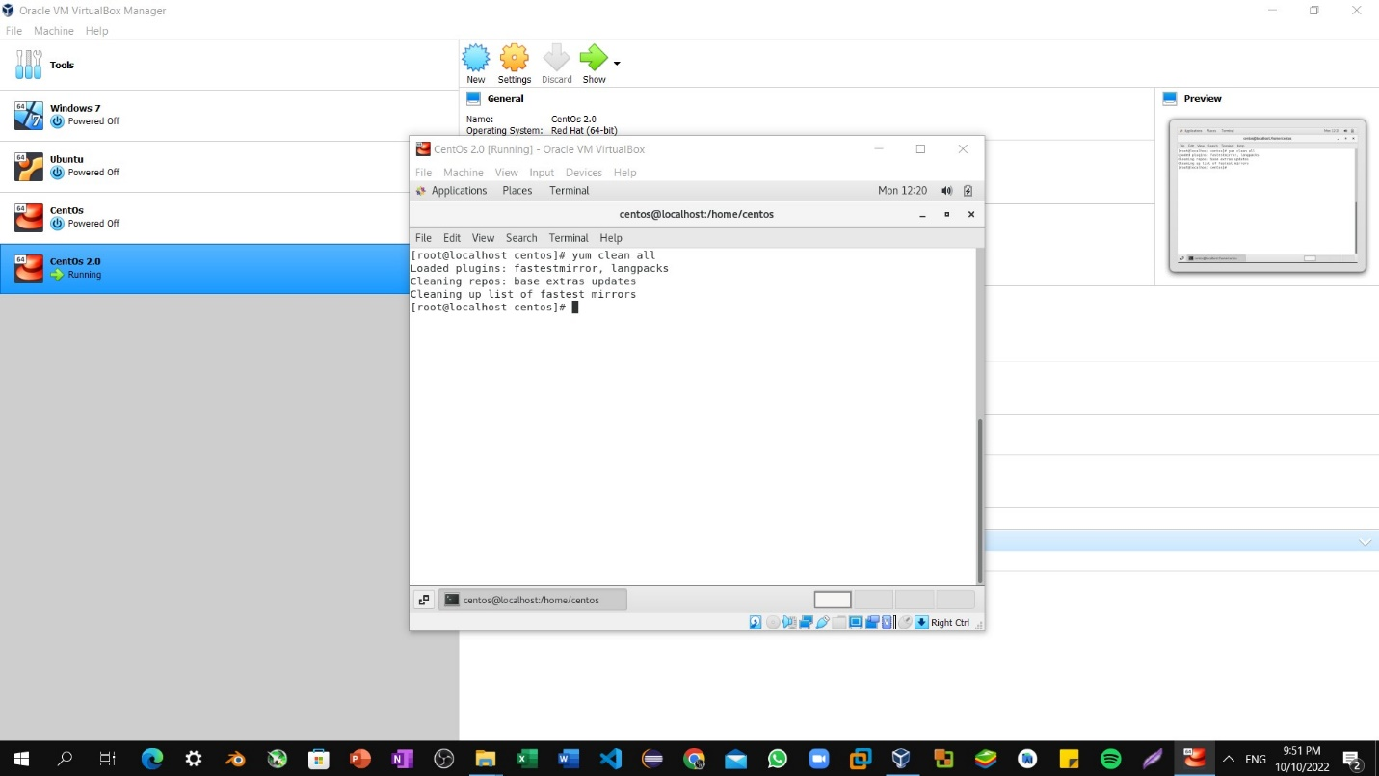

Step4: yum update: Enter the following commands in order for the operating system to be cleaned and updated. Then reboot your system.

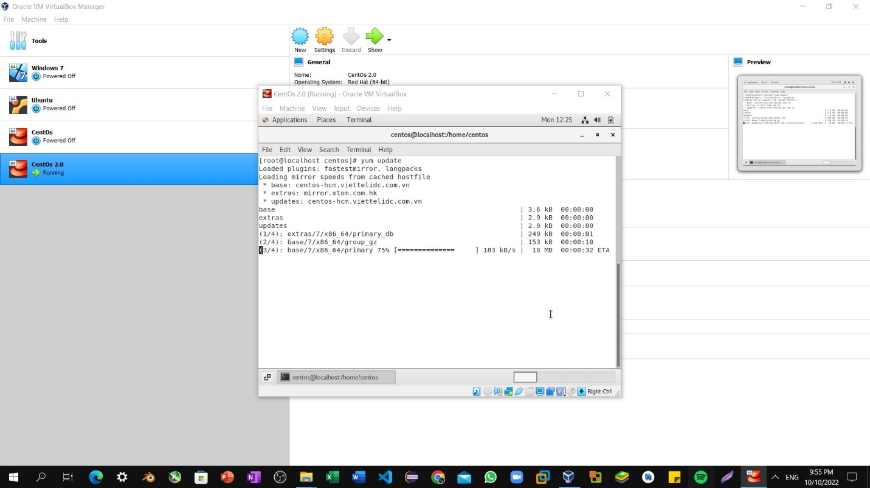

Step5: yum install -y qemu-kvm: This package provides the user-level KVM emulator and facilitates communication between hosts and guest virtual machines.

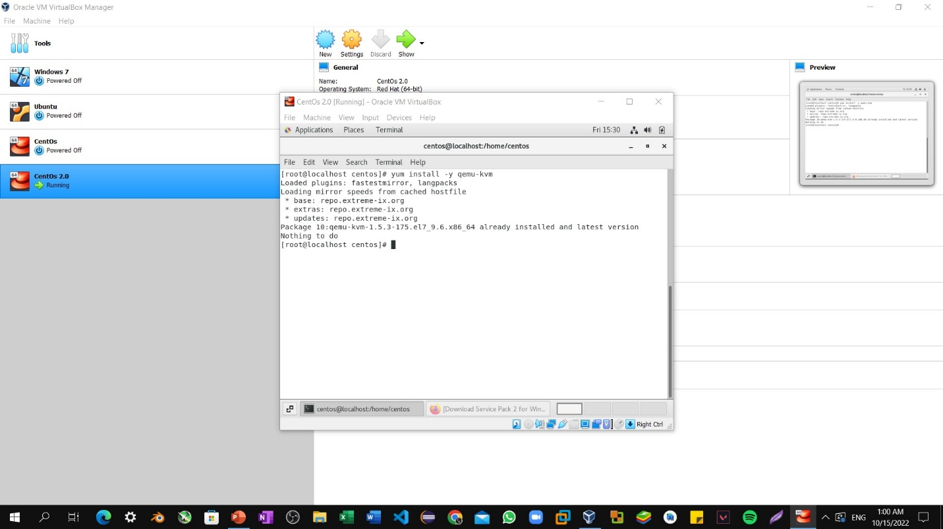

Step6: yum install -y qemu-img: This package provides disk management for guest virtual machines. The qemu-img package is installed as a dependency of the qemu-kvm package.

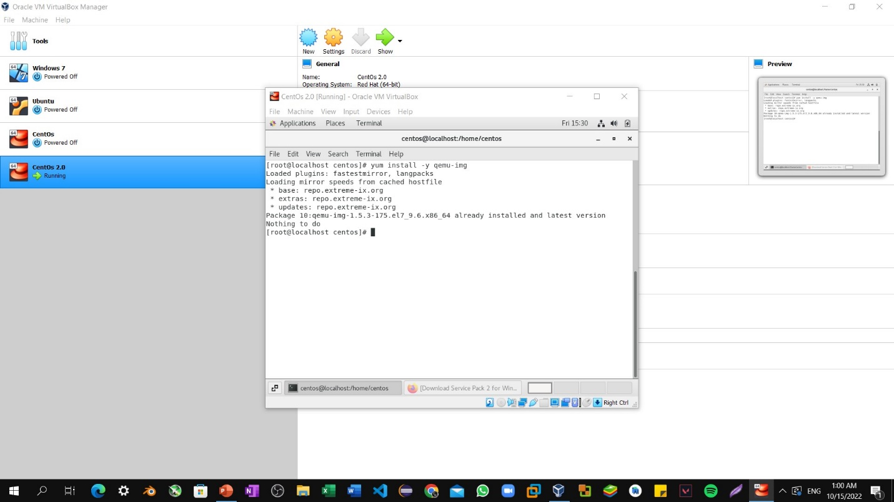

Step7: yum install -y libvirt: This package provides the server and host-side libraries for interacting with hypervisors and host systems.

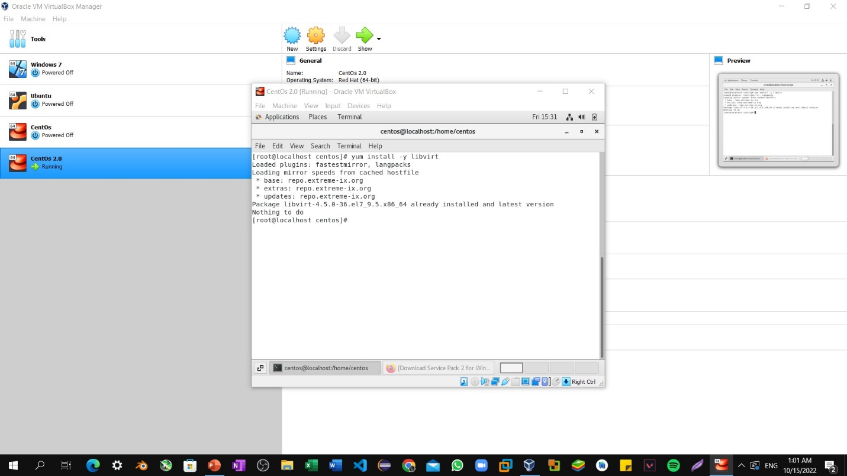

Step8: yum install -y virt-manager: This package provides the virt-manager tool, also known as Virtual Machine Manager.

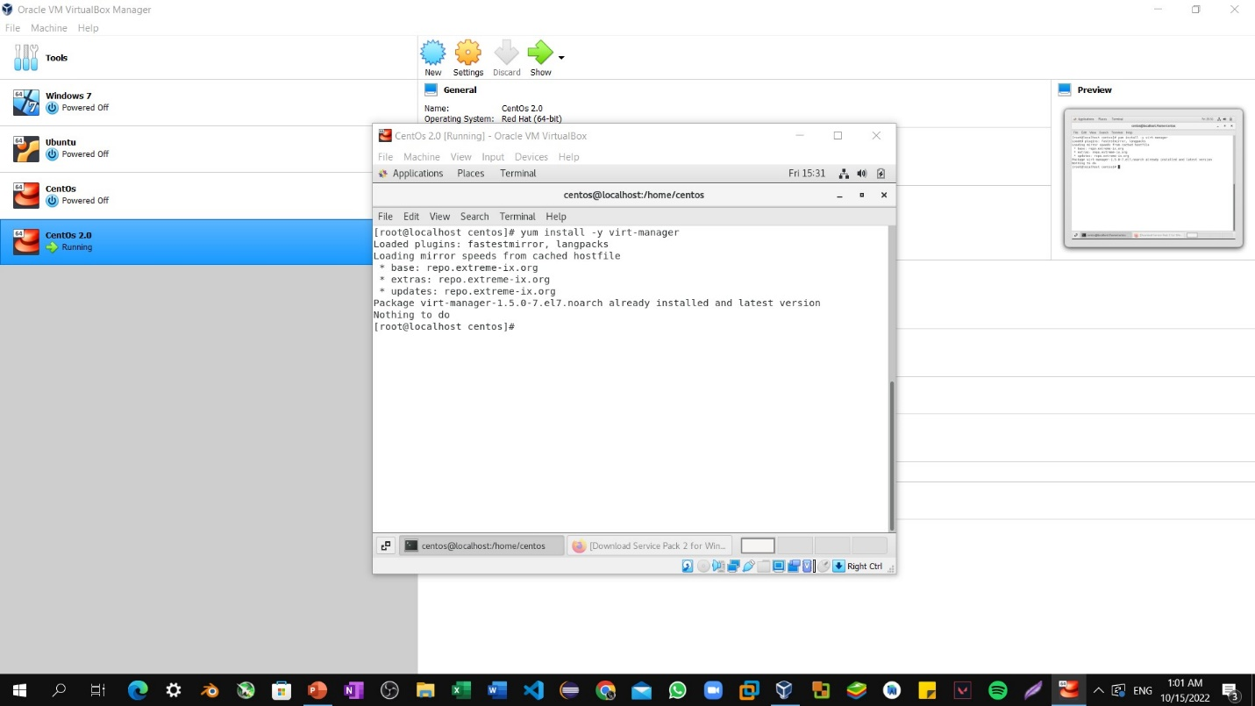

Step9: yum install -y libvirt-python: This package contains a module that permits applications written in the Python programming language to use the interface.

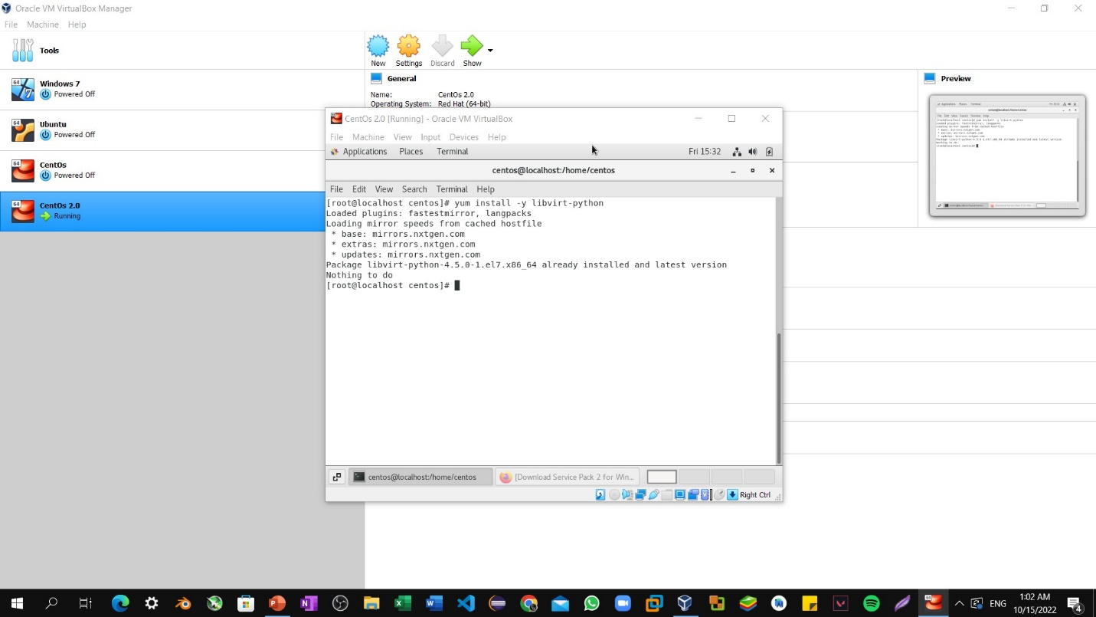

Step10: yum install -y virt-install: This package provides the virt-install command for creating virtual machines from the command line.

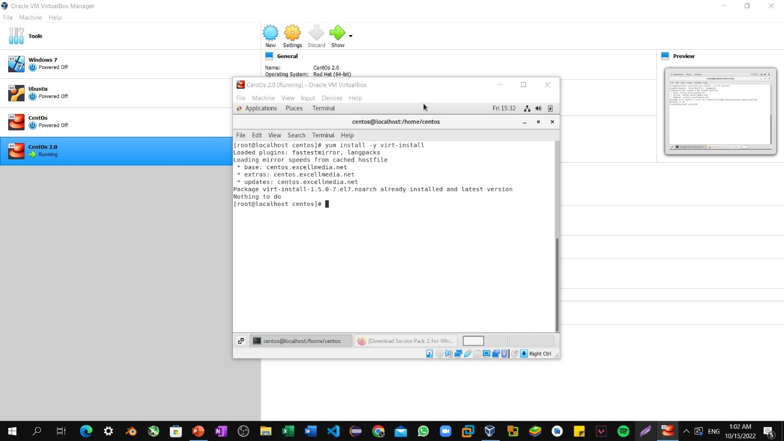

Step11: yum install -y libvirt-client: This package provides the client-side APIs and libraries for accessing libvirt servers.

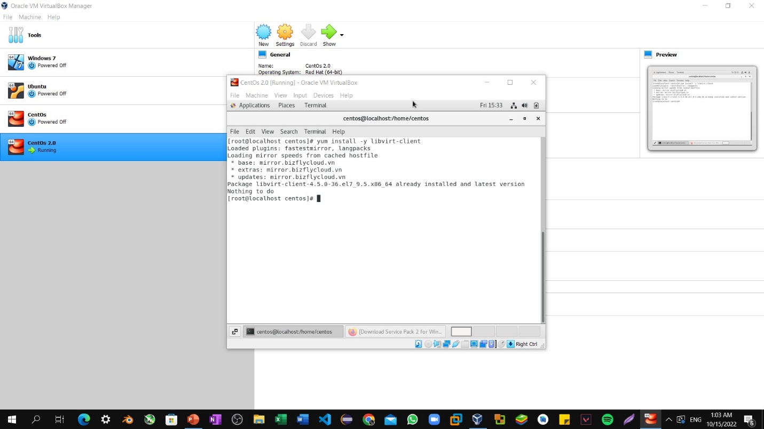

Step12: yum install -y virt-viewer: The virt-viewer package is designed for, Virtual Machine Viewer. Virtual Machine Viewer provides a graphical console client for connecting to virtual machines.

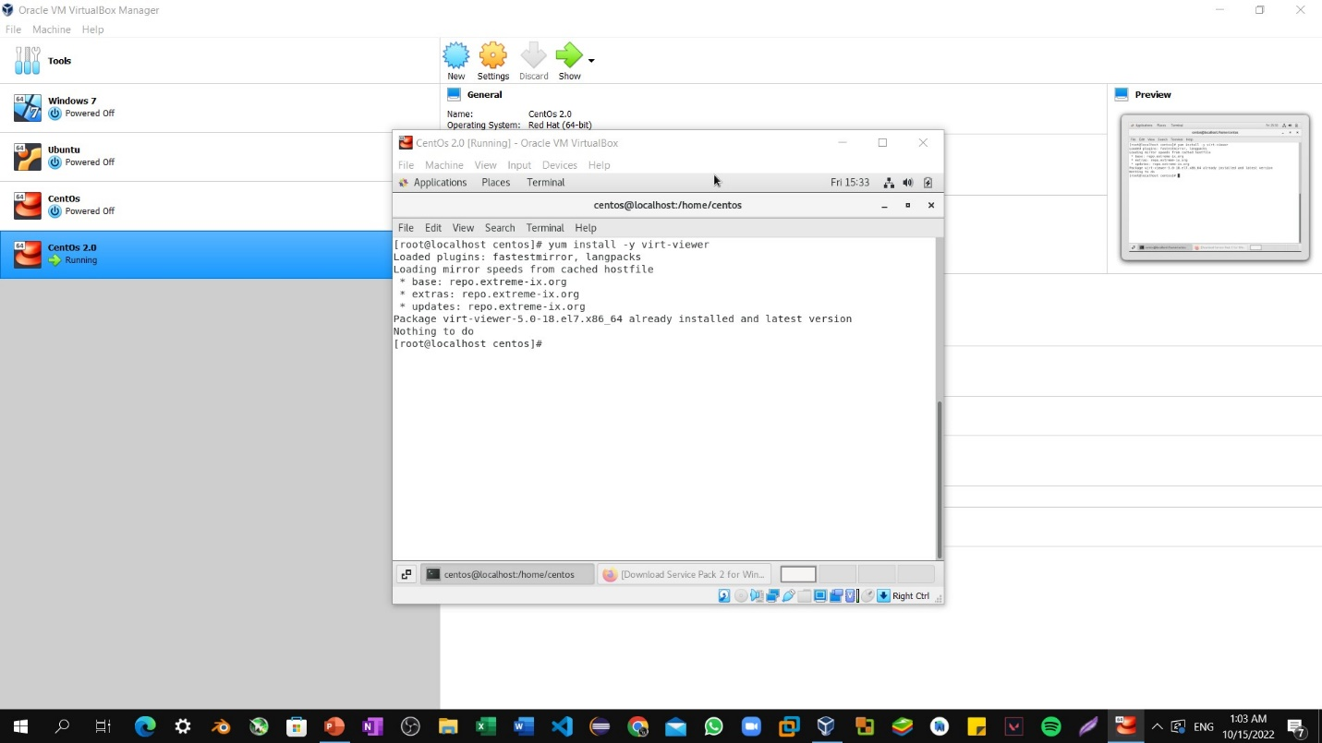

Step13: virt-manager: Opening KVM Interface.

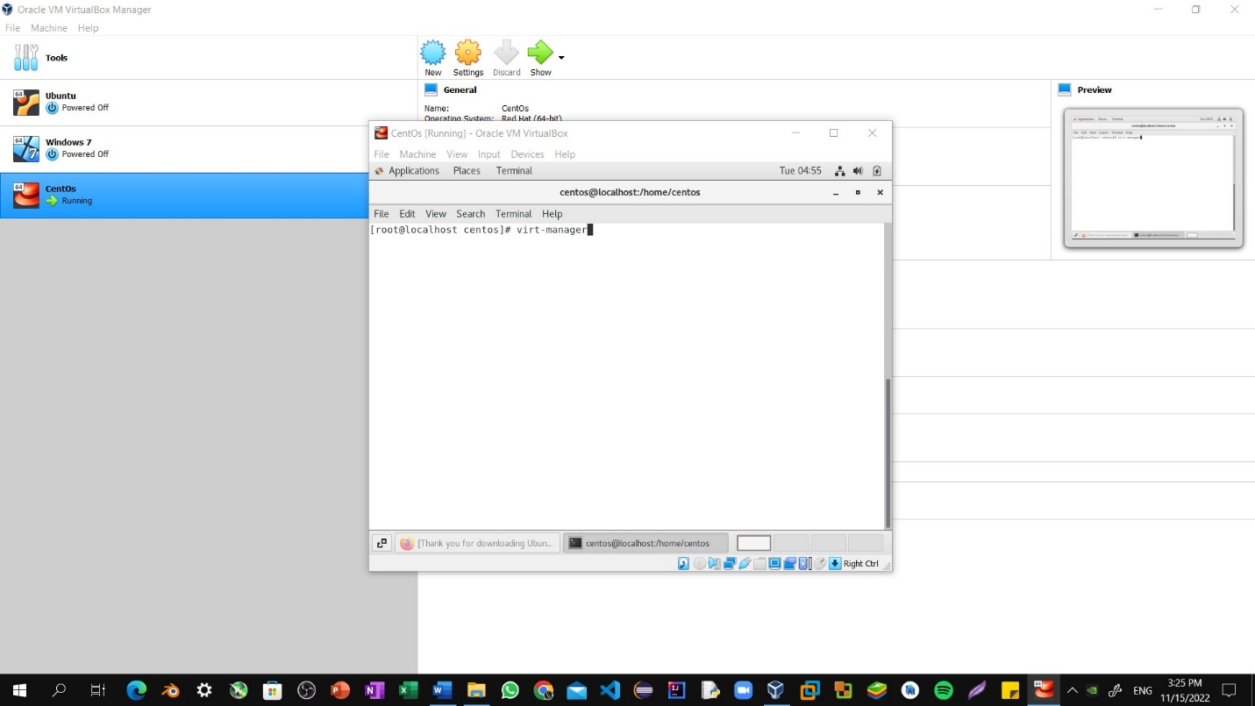

Step14: KVM Interface

